H.T No
Regulations:
A22

Sreenidhi Institute of Science and Technology
(An Autonomous Institution)
Code No: 9A201 Date: 18-Feb-2025 (FN)

B.Tech I-Year II- Semester External Examination, February-2025 (Supplementary)
ELECTRICAL CIRCUITS AND NETWORKS-I (EEE)

Time: 3 Hours Max.Marks:60

Note: a) No additional answer sheets will be provided.
b) All sub-parts of a question must be answered at one place only, otherwise it will not be valued.
c) Missing data can be assumed suitably.
Bloom's Cognitive Levels of Learning (BCLL)

Remember | L1 | Apply | L3 | Evaluate | L5
Understand | L2 | Analyze | L4 | Create | L6

Part - A Max.Marks: 6x2=12

Answer all QUESTIONS, EACH QUESTION CARRIES 2 MARKS.

 |  | BCLL | CO(s) | Marks
1 | Find the equivalent resistance for the given figure.  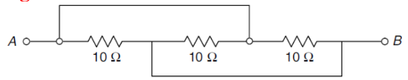 | L2 | CO1 | [2M]
2 | Write about the duality of a network. | L1 | CO2 | [2M]
3 | Define and write an equation for the coefficient of coupling. | L1 | CO3 | [2M]
4 | What is the relation between voltage and current in an AC circuit with a pure inductor? | L2 | CO4 | [2M]
5 | Define Band Width and Quality Factor. | L1 | CO5 | [2M]
6 | State Reciprocity theorem. | L1 | CO6 | [2M]

Part – B Max.Marks: 6x8=48
ANSWER ALL QUESTIONS. EACH QUESTION CARRIES 8 MARKS.

 |  | BCLL | CO(s) | Marks
7. | Find the voltage drop across the 5 Ω resistor in the network shown in Fig using the nodal analysis method.  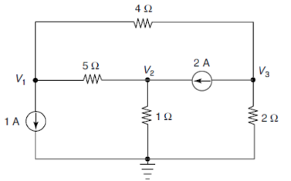 | L2 | CO1 | [8M]
 | OR
8 | Find V₀ using the source transformation technique.  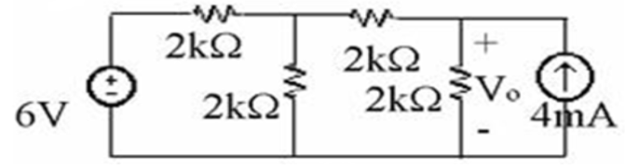 | L2 | CO1 | [8M]
9. | For the graph shown in Fig., write the incidence matrix, tie set matrix and f-cut set matrix.  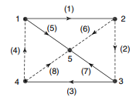 | L2 | CO2 | [8M]
 | OR
10 | For the network shown in Fig., draw the oriented graph. Write the tie-set schedule and obtain the equilibrium equation on a loop basis. Calculate the values of branch currents and branch voltages.  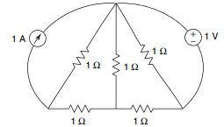 | L2 | CO2 | [8M]
11. | Derive the relation between self-inductances L₁ and L₂ and mutual inductance M of two coupled coils. | L2 | CO3 | [8M]
 | OR
12 | Find the equivalent inductance of the network shown in Fig.  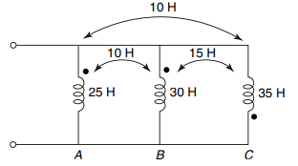 | L4 | CO3 | [8M]
13. | Explain the behavior of a pure capacitor in an AC circuit with a phasor diagram? | L2 | CO4 | [8M]
 | OR
14 | A resistance of 20Ω, an inductance of 0.2H, and a capacitance of 100μF are connected in series across 230V, 50Hz mains. Determine  - Impedance  - Current  - Voltage across R, L and C  - Active and apparent power  v. Power factor | L4 | CO4 | [8M]
15. | Draw the locus diagram of series R-L Circuit with R variable and explain. | L2 | CO5 | [8M]
 | OR
16 | A Series R-L-C Circuit is resonant at 1 megacycles/sec. Its bandwidth is 5000 cycles per second and input impedance at resonance is 50Ω.  Find R, L and C. | L4 | CO5 | [8M]
17. | Using super position theorem, find the current in 3Ω in the circuit shown  below  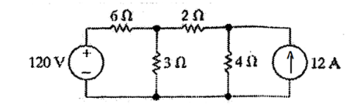 | L4 | CO6 | [8M]
 | OR
18 | Use Thevenin’s theorem to find the current through 5Ω resistor shown in figure below.  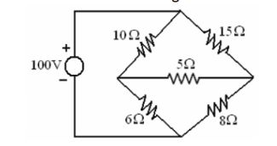 | L4 | CO6 | [8M]
-- 00 -- 00 –

